Đây là chương trình đèn giao thông điều khiển giao thông ngã tư.  
Mạch đã được test và chạy khá ổn định, mong rằng sẽ giúp ích cho các bạn  
sinh viên tham khảo để phục vụ tốt cho đồ án của mình.

Code:

AGRN equ P1.0

ARED equ P1.1

AYEL equ P1.2

BGRN equ P1.3

BRED equ P1.4

BYEL equ P1.5

LJMP INIT ;go to main

ORG 0013H ;EXT1 interrupt address

LJMP EXT1 ;go to EXT1 Interrupt handler

LJMP MAIN ;Then go back to main routine

INIT:

MOV SP,#20h ;Move SP beyond internal reg's

LCALL CLR_LCD ;clear that LCD

LCALL ENABLE_INTS ;Enable Intterrupts as we see fit

MAIN:

CALL CLEAR_ALL

SETB BRED

SETB AGRN

MOV R0,#06H ; WAIT BEFORE LIGHTS START TO CHANGE

LOOP1: LCALL ONESEC

DJNZ R0,LOOP1

CALL CLEAR_ALL

SETB BRED

SETB AYEL

LCALL ONESEC ; WAIT FOR 1 SEC TO CHANGE FROM YELLOW TO RED

CALL CLEAR_ALL

SETB ARED

SETB BRED

LCALL ONESEC

CALL CLEAR_ALL

SETB ARED

SETB BGRN

MOV R0,#06H ; WAIT BEFORE LIGHTS START TO CHANGE

LOOP2: LCALL ONESEC

DJNZ R0,LOOP2

CALL CLEAR_ALL

SETB ARED

SETB BYEL

LCALL ONESEC ; WAIT FOR 1 SEC TO CHANGE FROM YELLOW TO RED

CALL CLEAR_ALL

SETB ARED

SETB BRED

LCALL ONESEC

JMP MAIN

;EXT1 Interrupte Handling Routine

EXT1:

SETB ACC.0 ; set a flag on the ACC

RETI

;Subroutines

CLR_LCD:

MOV P0, #00h

RET

ENABLE_INTS:

SETB IT1 ;Set EXT1 to falling edge active

SETB EX1 ;Enable EXT1

MOV TMOD,#01H ; SET 16 BIT COUNTER

SETB EA ;Enable Global Interrupts to occur

RET

; CLEARS ALL THE LIGHTS

CLEAR_ALL:

MOV P1,#00H ; clear all lights

CLR ACC.0 ; clear interrupt flag

RET

; COUNT FOR ONE SECOND

ONESEC:

MOV R1,#14H ; COUNTER USED TO LOOP 20 TIMES, WHICH IS EQUIVALENT TO 1 SEC

SEC_LOOP:

MOV TH0,#00H ; CLEAR TIMER 0

MOV TL0,#00H

CLR TF0 ; CLEAR OVERFLOW BIT

SETB TR0 ; START TIMER 0

JNB TF0,$ ; WAIT FOR OVERFLOW FLAG

CLR TR0 ; STOP TIMER 0

JNZ BTN_PRESSED ; CROSSWALK BUTTON WAS PRESSED, JUMP OUT OF LOOP

DJNZ R1,SEC_LOOP

BTN_PRESSED:

RET

HALT: JMP $

END

ơ đồ mạch đèn gthong!

Attached Files

* [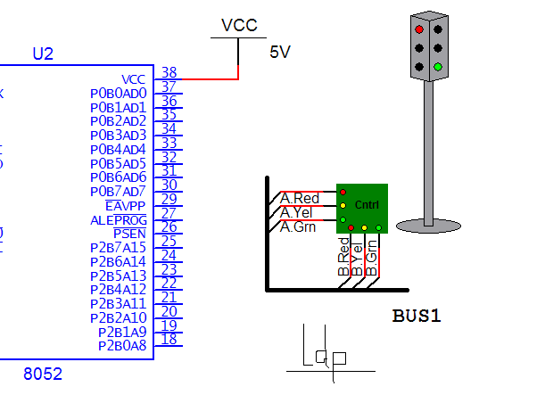](http://www.dientuvietnam.net/forums/filedata/fetch?id=1326912)
* [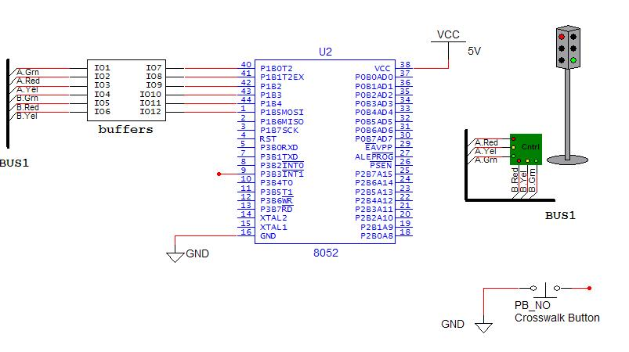](http://www.dientuvietnam.net/forums/filedata/fetch?id=1326913)